

IDEA Exercise II
03/31/2024

By
Mahjoube AmaniChakani, Maya Krishnan, Ogochukwu Onyeso, Nkasiobi Nwobi

Contents
Pre-Analysis 3
❖ Research Question and DAG 3
❖ Data cleaning and Acquisition steps 3
❖ Main Variables Used 4
❖ Changing variables name 5
Analysis steps 6
❖ Descriptive statistics 6
❖ Test of statistics(chi2): 8
❖ Model Comparison and Selection: Evaluating the Best Model Based on AIC and BIC 8
❖ Logistic Regression-Final Model 10
❖ Stratifying by group_ Intersectionality 12
❖ Plot the result 14
❖ Superdiversity 16

Pre-Analysis

Research Question and DAG
We are trying to answer the following question based on the following DAG:
How does immigration status contribute to employment inequality in Canada, and how do race, language proficiency, gender, and education level shape this relationship?
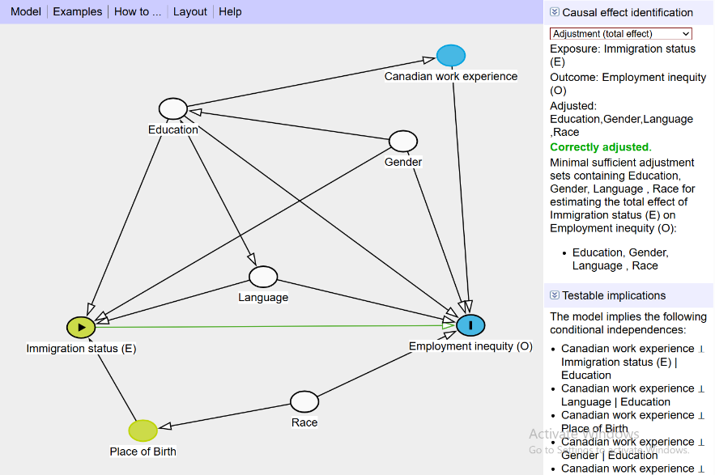

Data cleaning and Acquisition steps
The 2021 Census Public Use Microdata File (PUMF) dataset underwent thorough data refinement, including recoding and renaming variables to enhance clarity and interpretability (see Appendix for details). The sample was restricted to working-age individuals (15-69 years old) to focus on labor market outcomes. Steps:
- Keep relevant variables: reduce from 141 to 44 variables to choose final variables based on their statistical significance in the model
- Label values and assign descriptive labels to variables
- Keep only relevant working-age groups (15-69 years)
- Separate main variables and derived variables
- Generate employment status variable (employed): 0 for unemployed and 1 for employed
- Generate Job_permanency variable (working in permanent jobs or not)
- Generate binary variable for race (non_white): 0 for white and 1 for non-white
- Generate language proficiency indicator (lang_proficient): 1 for speaks English or French and 0 for neither English nor French
- Generate education level variable (uni_educated): 1 for bachelor's degree or higher and 0 for no university degree
- Generate visible minority indicator (visible_minority): 1 for visible minority and 0 for not visible minority
- Label values for new derived variables, mostly using binary categories defined above

Main Variables Used
 |  | Original Name/Source |  | Derived or Re-Coded Version
Immigration status | - Immigrant_status: immstat (1 non-immigrants, 2 immigrants, 3 non-permanent residents)
Admission category | - immcat5 (1 non-immigrants, 2 non-permanent residents, 3 immigrants before 1980, 21 economic immigrants, 22 family-sponsored immigrants, 23 other)
Employment Status | - fptwk (1 full-time, 2 part-time)  - jobperm (1 unpaid/self-employed, 2 permanent employee, 3 fixed-term/casual/seasonal)  - Labour_force_status : lfact (Labour force status - Detailed )->1 "Employed - Worked in reference week" 2 "Employed - Absent in reference week" 3 "Unemployed - Temporary layoff - Did not look for work" 4 "Unemployed - Temporary layoff - Looked for full-time work" 5 "Unemployed - Temporary layoff - Looked for part-time work" 6 "Unemployed - New job - Did not look for work" 7 "Unemployed - New job - Looked for full-time work" 8 "Unemployed - New job - Looked for part-time work" 9 "Unemployed - Looked for full-time work" 10 "Unemployed - Looked for part-time work" 11 "Not in the labour force - Last worked in 2021" 12 "Not in the labour force - Last worked in 2020" 13 "Not in the labour force - Last worked before 2020" 14 "Not in the labour force - Never worked" |  | - employed (0 unemployed, 1 employed)  - Jobpermanency : Job_permanency (derived from jobperm) -> 0 "non permanent position(job)" 1 " permanent position(job)"  - lico_bt: Lowe_Income_Status_before_tax
Age groups | - agegrp
Age groups at time of immigration | - ageimm
Education | - Attsch(School attendance – Detailed)  - Highest_certificate: hdgree (1 "No certificate, diploma or degree" 2 "High (secondary) school diploma or equivalency certificate" 3 "Non-apprenticeship trades certificate or diploma" 4 "Apprenticeship certificate" 5 "Program of 3 months to less than 1 year (college, CEGEP and other non-university certificates or diplomas)" 6 "Program of 1 to 2 years (college, CEGEP and other non-university certificates or diplomas)" 7 "Program of more than 2 years (college, CEGEP and other non-university certificates or diplomas)" 8 "University certificate or diploma below bachelor level" 9 "Bachelor's degree" 10 "University certificate or diploma above bachelor level" 11 "Degree in medicine, dentistry, veterinary medicine or optometry" 12 "Master's degree" 13) |  | uni_educated (1 university degree or higher, 0 no university degree)
Labour: Class of worker | - Class_of_worker: cow (1 "Employee" 2 "Unpaid family worker" 3 "Self-employed, without paid help, incorporated" 4 "Self-employed, with paid help, incorporated" 5 "Self-employed, without paid help, unincorporated" 6)
Citizenship: Other country of citizenship | - citoth (1 United States, 2 other Americas, 3 UK, 4 other Europe, 5 Africa, 6 West/Central Asia & Middle East, 7 China, 8 other East Asia, 9 Philippines, 10 other Southeast Asia, 11 India, 12 other South Asia, 13 Oceania, 14 two other countries, 15 no other citizenship)  - citizen (1 Canadian by birth, 2 naturalized, 3 not a citizen)
Race and ethnicity | - dpgrsum (1 "White" 2 "South Asian" 3 "Chinese" 4 "Black" 5 "Filipino" 6 "Arab" 7 "Latin American" 8 "Southeast Asian" 9 "West Asian" 10 "Korean" 11 "Japanese" 12 "Other population groups, n.i.e." 13 "Other multiple population groups" 14 "Indigenous peoples" )  - ethder (1 "North American Indigenous origins" 2 "Acadian" 3 "Canadian" 4 "French Canadian" 5 "Québécois" 6 "Other North American origins" 7 "English" 8 "Irish" 9 "Scottish" 10 "Other British Isles origins" 11 "French origins" 12 "Dutch" 13 "German" 14 "Other Western European origins" 15 "Other Northern European origins" 16 "Greek" 17 "Italian" 18 "Portuguese" 19 "Other Southern European origins" 20 "Romanian" 21 "Other Southeast European origins" 22 "Hungarian" 23 "Polish" 24 "Russian" 25 "Ukrainian" 26 "Other Eastern European origins" 27 "Other European origins" 28 "Haitian" 29 "Jamaican" 30 "Other Caribbean origins" 31 "Mexican" 32 "Other Latin, Central and South American origins" 33 "Central and West African origins" 34 "North African origins" 35 "Southern and East African origins" 36 "Other African origins" 37 "Afghan" 38 "Iranian" 39 "Lebanese" 40 "Other West and Central Asian and Middle Eastern origins" 41 "Indian (India)" 42 "Pakistani" 43 "Punjabi" 44 "Sri Lankan" 45 "Other South Asian origins" 46 "Chinese" 47 "Filipino" 48 "Korean" 49 "Vietnamese" 50 "East and Southeast Asian origins, n.i.e." 51 "Other Asian origins" 52 "Arab, n.o.s." 53 "Caucasian (White), n.o.s." 54 "Christian, n.i.e." 55 "Hindu" 56 "Jewish" 57 "Sikh" 58 "Other ethnic and cultural origins" 59 "Multiple ethnic or cultural origins")
Language proficiency | - Knowledge_of_lang: kol (1 "English only" 2 "French only" 3 "English and French" 4 "Neither English nor French" 8 "Not available"  - fol ->1 "English" 2 "French" 3 "English and French" 4 "Neither English nor French"  - hlmosten(Language spoken most often at home – English)) |  | lang_proficient (1 speaks English or French, 0 neither)
sex at birth | - gender (1 woman+, 2 man+)
Generation status" refers to whether or not the person or the person's parents were born in Canada | - genstat (1 first generation born outside Canada, 2 second generation both parents born outside Canada, 3 second generation one parent born outside Canada, 4 third generation or more)
Place of birth of person | - pob (1 "Canada" 2 "United States" 3 "Central America" 4 "Jamaica" 5 "Other Caribbean and Bermuda" 6 "South America" 7 "United Kingdom" 8 "Germany" 9 "France" 10 "Other Northern and Western Europe" 11 "Poland" 12 "Other Eastern Europe" 13 "Italy" 14 "Portugal" 15 "Other Southern Europe" 16 "Eastern Africa" 17 "Northern Africa" 18 "Other Africa" 19 "Iran" 20 "Other West Central Asia and the Middle East" 21 "China" 22 "Hong Kong" 23 "South Korea" 24 "Other Eastern Asia" 25 "Philippines" 26 "Viet Nam" 27 "Other Southeast Asia" 28 "India" 29 "Pakistan" 30 "Sri Lanka" 31 "Other Southern Asia" 32 "Oceania and others" 88 "Not available")  - pob (1 Canada, 2-32 other countries, 88 not available)
Province or territory of current residence (2021) | - Province :pr (10 Newfoundland, 11 PEI, 12 Nova Scotia, 13 New Brunswick, 24 Quebec, 35 Ontario, 46 Manitoba, 47 Saskatchewan, 48 Alberta, 59 BC, 70 Northern Canada)
Visible minority | - Visibleminority : Vismin (1 "Not a visible minority" 2 "South Asian" 3 "Chinese" 4 "Black" 5 "Filipino" 6 "Arab" 7 "Latin American" 8 "Southeast Asian" 9 "West Asian" 10 "Korean" 11 "Japanese" 12 "Visible minority, n.i.e." 13 "Multiple visible minorities) |  | visible_minority (0 not visible minority, 1 visible minority)
survey weights | - weight

Changing variables name
rename vismin Visibleminority
rename pr Province
rename pob Place_of_birth
rename noc21 Occupation_Major_Group
rename lico_at Lowe_Income_Status_after_tax
rename lico_bt Lowe_Income_Status_before_tax

rename lfact Labour_force_status
rename kol Knowledge_of_lang
rename jobperm Jobpermanency
rename immstat Immigrant_status
rename immcat5 Admission_category
rename hdgree Highest_certificate
rename genstat Generation_status
rename cow Class_of_worker

Analysis steps

Descriptive statistics
Descriptive statistics were computed for key demographic and socioeconomic variables, providing an overview of employment patterns across different groups. The primary exposure variable, immigration status, was examined in relation to the outcome variable, employment status, while controlling for key confounders: education, gender, language proficiency, Place of birth, and visible minority and race. All numbers in these tables are based on weighted sample:

Test of statistics(chi2):

Because our dependent variable is categorical, a chi-squared test is appropriate to assess the relationship between employment status and immigration status. In both cases There is a highly significant result (p < 0.001), meaning there is strong evidence that employment status varies by immigration status. The survey-weighted cross-tabulation reveals that employment rates are similar across non-immigrants (65.23%), immigrants (65.01%), and non-permanent residents (66.32%) but highest unemployment is for immigrants. While these differences appear small, the design-based F-test (p = 0.001) confirms that the relationship between immigrant status and employment status is statistically significant. This suggests that immigrant and non-permanent residents’ labour market outcomes differ in ways that may not be fully captured by employment rates alone and we will do the intersectionality analysis to find the main pattern.

Model Comparison and Selection: Evaluating the Best Model Based on AIC and BIC
To assess the factors associated with employment status, five logit regression models were estimated. Each model included varying sets of explanatory variables to progressively account for individual characteristics, human capital, and sociodemographic factors to compare coefficients and best fit.
Model 1: Employment status regressed on immigration status only.
Model 2: Employment status regressed on immigration status, gender, detailed education (13 categories), official language knowledge (English/French), and detailed visible minority status (13 categories).
Model 3: Employment status regressed on immigration status, gender, detailed education (13 categories), official language knowledge, and detailed population group (race/ethnicity - 13 categories).
Model 4: Employment status regressed on immigration status, gender, detailed education (13 categories), official language knowledge, and place of birth (country level).
Model 5: Employment status regressed on immigration status, gender, detailed education (13 categories), official language knowledge, and binary visible minority status (visible minority vs. not).Model 6: Change education to the binary form
Below summarizes the key fit statistics for each model:
*p<0.5, **p<.01; ***p<.001 1:Model Fit Comparison
To assess the factors associated with employment status, a series of nested logit regression models were estimated and compared using AIC and BIC. While Model 4 achieved the lowest AIC and BIC, indicating the best overall fit, Model 3 was selected as the final model because it provided clearer evidence of the relationship between immigrant status and employment. This allows the model to capture how immigration status and race jointly shape employment inequality, aligning with an intersectional approach that recognizes these social positions as mutually shaping experiences in the labour market. By controlling for relevant confounders, Model 3 offers a focused and theoretically grounded basis for understanding the racialized dimensions of immigrant employment inequality in Canada.

Logistic Regression-Final Model
To estimate the relationship between immigration status and employment status, a logistic regression model was employed. The model adjusts for the minimal sufficient adjustment set identified through Directed Acyclic Graph (DAG) analysis, as well as insights from model comparison to select the best-fitting model. Based on the DAG, the primary goal is to estimate the effect of immigration status on employment status, while accounting for the intersecting roles of race and visible minority status, and adjusting for key confounders such as education, gender, and language proficiency.
Overall, men have significantly higher odds of employment than women, and higher educational attainment is strongly associated with better employment outcomes. Language proficiency also matters, with bilingual individuals (English and French) having the highest employment odds, while those who speak neither official language face substantial disadvantages. Immigrants and native-born individuals have very similar employment odds but lower for immigrants. Non-permanent residents, however, face a clear disadvantage in employment, with significantly lower odds of being employed compared to native-born individuals. Furthermore, racial and ethnic disparities are evident, with Black, South Asian, Indigenous, and several other racialized groups facing lower odds of employment compared to the reference population.
The table below presents the average marginal effects derived from the logistic regression model:
Non-permanent residents face a 1.4 percentage point lower probability of employment compared to non-immigrants, while immigrants themselves do not show a statistically significant difference. Racial and ethnic inequalities are also evident, with South Asian, Black, Filipino, Arab, Indigenous, and several other racialized groups experiencing significantly lower probabilities of employment, even after controlling for education, language, gender, and immigration status.

Stratifying by group_ Intersectionality
/*option1: based on employment and immigration status*/
Across all three models, racialized groups (visible minorities) consistently have lower odds of employment compared to the reference group. South Asians have significantly lower odds of employment in all three groups. Non-permanent residents face the steepest disadvantages, especially if they are racialized. Immigrants benefit more from education than non-immigrants, but racial penalties still exist. Language proficiency is crucial, especially for immigrants and non-permanent residents. Across all groups, speaking neither English nor French is associated with a major unemployment.
/*option2: based on income and immigration status*/
Employment alone does not capture economic security; many employed individuals, particularly racialized and immigrant workers, still experience low income due to precarious work and wage gaps. To capture this economic dimension, option 2 shifts the focus from employment to income status. For non-immigrants, racialized groups like South Asians, Black individuals, and Arabs face substantially higher odds of being in low income compared to non-visible minorities. This confirms persistent racial economic inequality even for the Canadian-born. For immigrants, racial penalties are even larger, meaning that racialized immigrants face a double disadvantage (as both immigrants and racial minorities). Black immigrants, for example, are at particularly high risk. For non-permanent residents, the results are somewhat more variable, but South Asians and Black individuals still face sharply higher odds of low income.

Plot the result
First model:
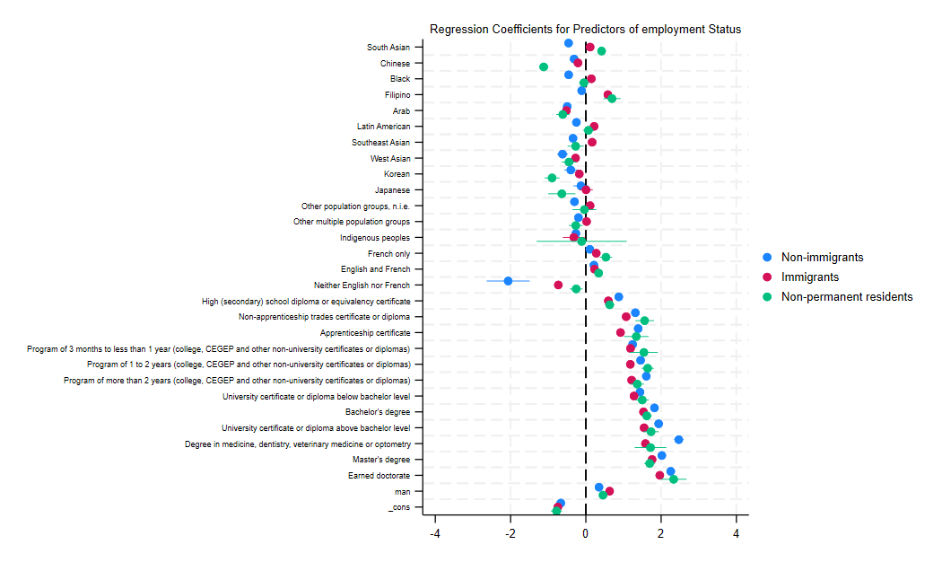
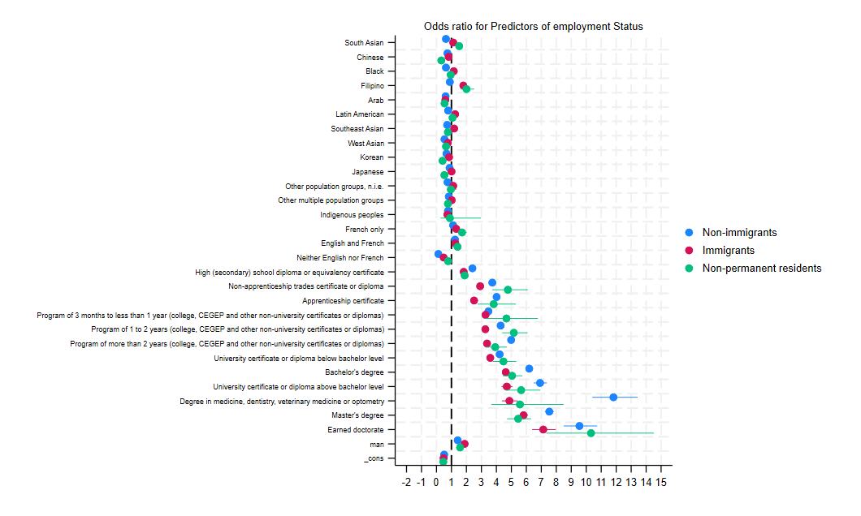

Second Model:
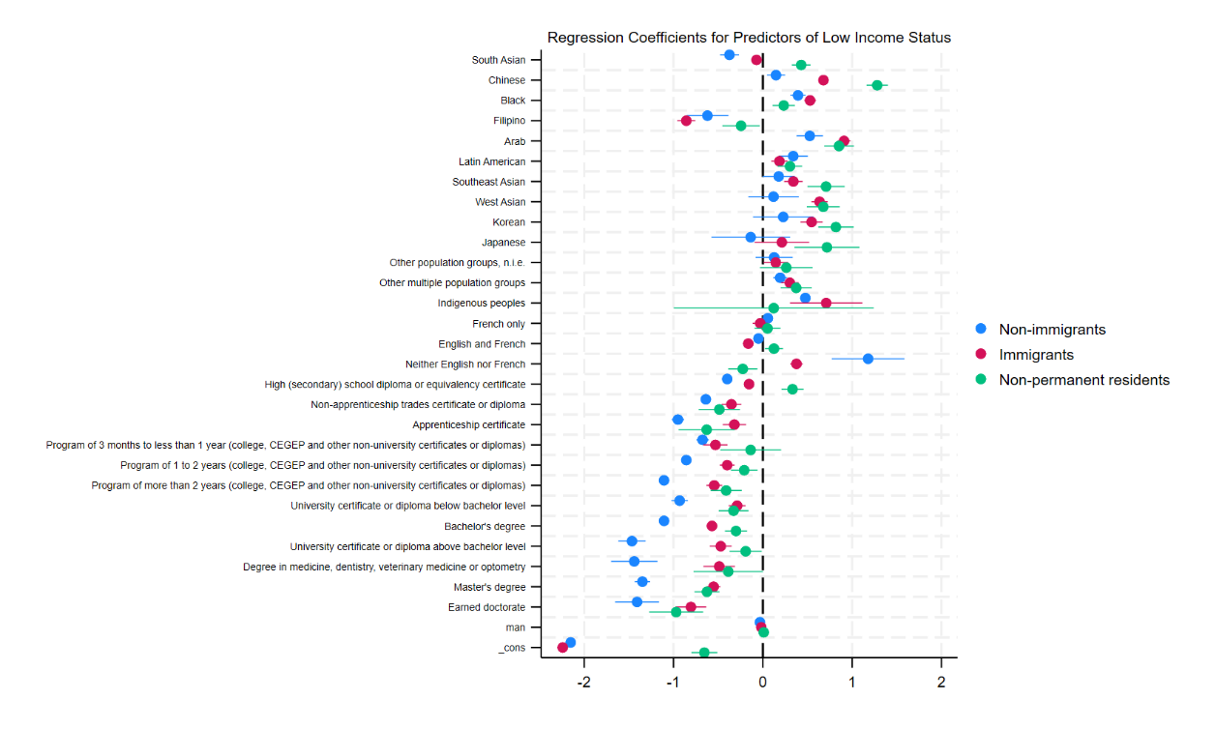
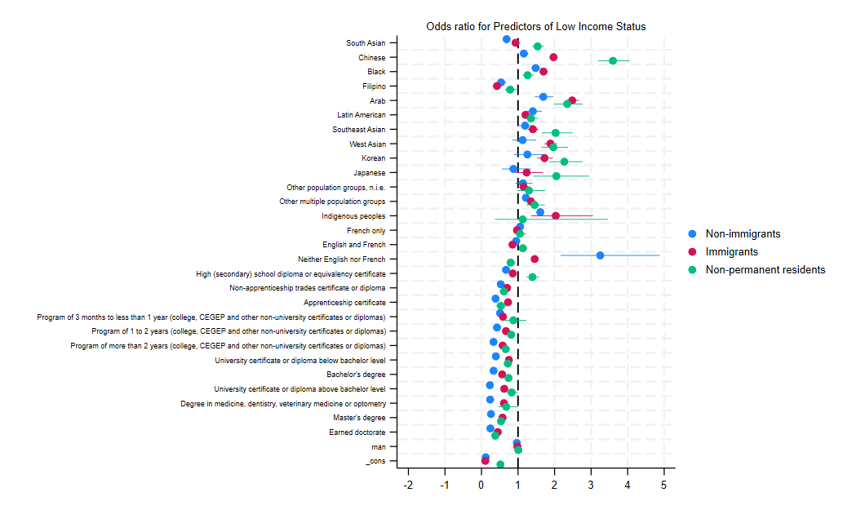

Superdiversity
Immigrants aged 18-64, any ethnicity, any visa type | White immigrants, age 18-64, any visa type
Vancouver
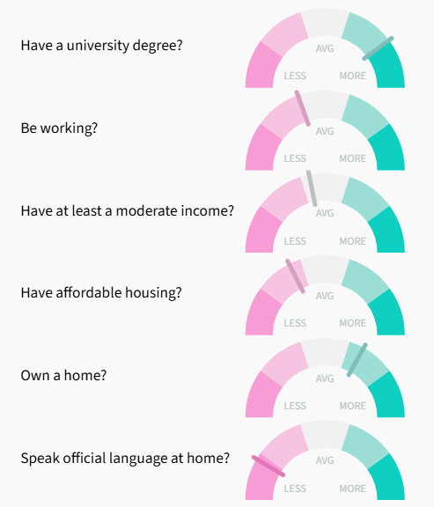 | 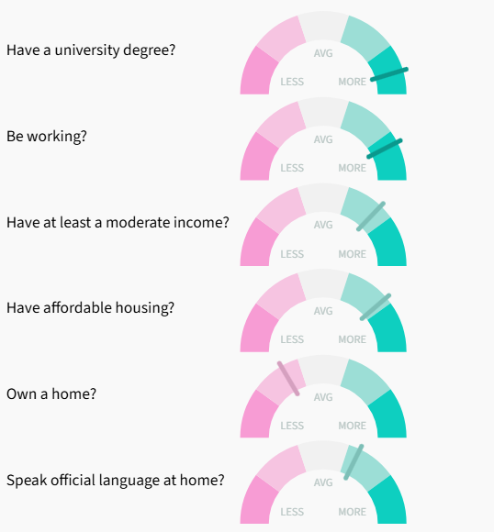
Toronto
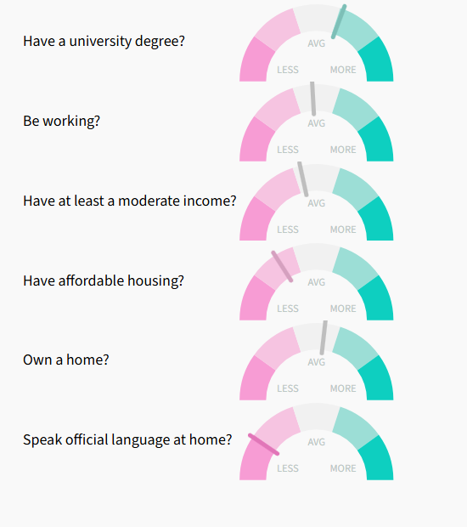 | 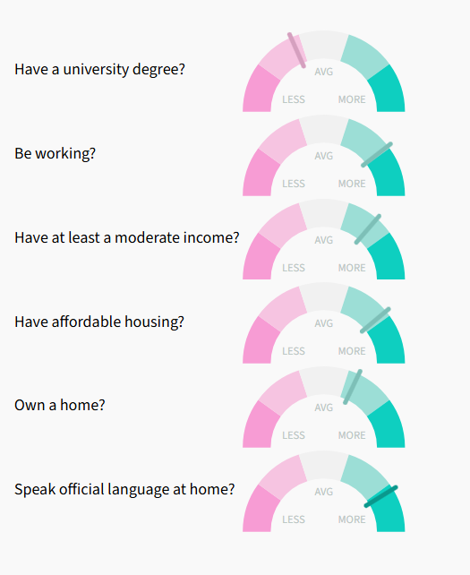
Montreal
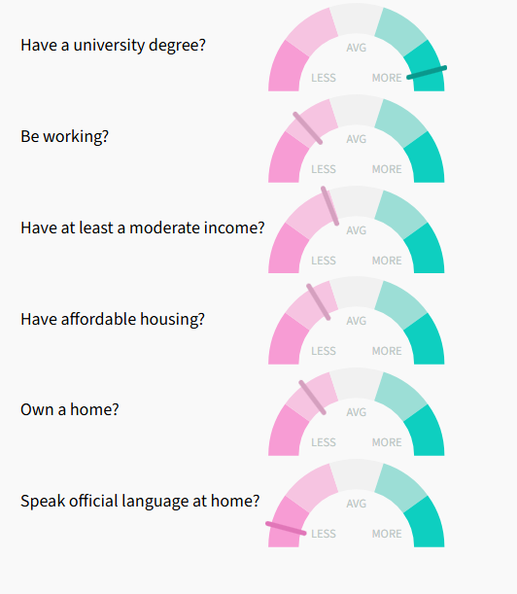 | 